‘Amy’ - Cleared photos for publicity use – Free To Use:

Copyright: Alex Lake
Photo id: AlexLake_KK6N2623
Notes: Amy Winehouse

Copyright: Getty Images
Photo id: Getty_114621824
Notes: Amy Winehouse performing at MTV Movies Awards, 2007

Copyright: Getty Images
Photo id: Getty_116794544
Notes: Amy Winehouse performing at Joe’s Pub, NYC, 2007

Copyright: IPC Media / Tom Oxley
Photo id: IPC_TomOxley_1057604
Notes: Amy Winehouse Backstage at Koko, Camden Town, 2006

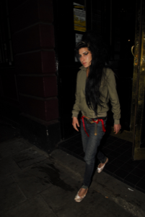 | Copyright: Optic Photos  Photo id: P25376.OPTIC AMY_BLAKE_FLAT 280307_66  Notes: Amy Winehouse – March 2007
Copyright: WENN Ltd
Photo id: P31597.highres.WENN.29July2006.Amy leaving bar.wenn761553
Notes: Amy Winehouse – July 2006
Copyright: Rex Features
Photo id: rexfeatures_483743h
Notes: Amy Winehouse – V Festival August 2004
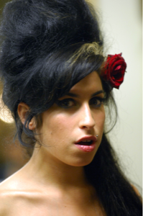 | Copyright: Rex Features  Photo id: rexfeatures_634001bi  Notes: Amy Winehouse – The South Bank Show Awards January 2007
Copyright: Rex Features
Photo id: rexfeatures_661742c
Notes: Amy Winehouse – NYC May 2007
Copyright: Rex Features
Photo id: rexfeatures_671141h
Notes: Amy Winehouse – Parkinson TV Show June 2007
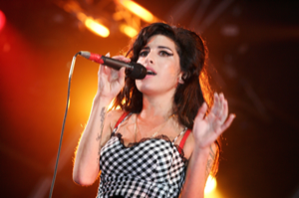 | Copyright: Rex Features  Photo id: rexfeatures_679380o  Notes: Amy Winehouse – Somerset House July 2007
Copyright: Rex Features
Photo id: rexfeatures_731998bd
Notes: Amy Winehouse – Grammys February 2008
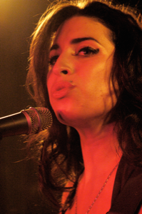 | Copyright: Rex Features  Photo id: rexfeatures_3494544a  Notes: Amy Winehouse – Barfly Club Camden March 2004
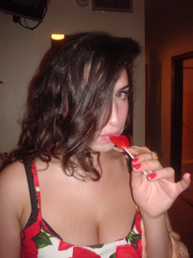 | Copyright: Nick Shymansky  Photo id: P1494.NickShymansky  Notes: Amy Winehouse -  Credit: Photo by Nick Shymansky

